Perform the following directory creation tasks and write down the commands used:
a. Create a directory named my_directory
b. Inside my_directory , create another directory named our_directory
c. Create a hidden directory named .new_directory
d. Create a directory named pictures with the following subdirectories:
vacation
family
friends
e. Create a directory named dir1
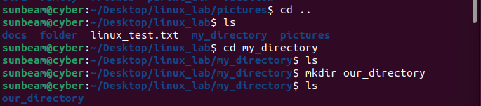
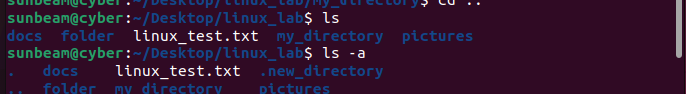
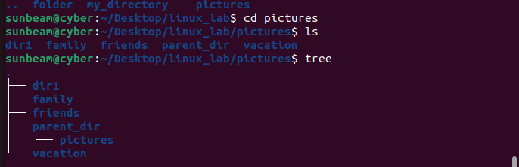

Practice additional mkdir options:
-p : Create parent directories if they do not exist
-m : Set permissions while creating a directory
-v : Show verbose output
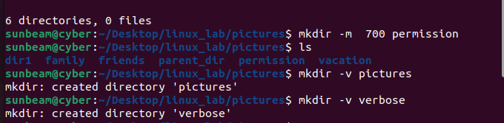
Delete the directory named dir1
Delete the directory named pictures (including its subdirectories)
